10/23/25
Anirudh Krishna
Deepan Idayachandiran

2025 Quadratic Sort lab

*Link to Dataset: https://catalog.data.gov/dataset/listing-of-active-businesses
*Link to spreadsheet(input data for graphs in Part B): https://docs.google.com/spreadsheets/d/12c_j_92rsmykfZvpjbfiB-kJUpbpxm60nWlX9pK0Sxw/edit?usp=sharing
*Link to code that we used (will be discussed further in part C):
https://drive.google.com/file/d/1U5DqzRAI8RUw3ztMuDgx-11NPkwdJaiy/view?usp=sharing

Different types of sorts discussed throughout the report:

Bubble sort:

Bubble sort is an algorithm designed to move the highest value that is in focus all the way to the back of the array, while the lower values “bubble” to the front over time. The average time complexity is O(n^2), the worst case time complexity is O(n^2), the best case time complexity is O(n).

Selection Sort:

Selection Sort is an algorithm that first looks through the array n-1(or m) times, then finds the smallest element, and moves it to the back, then it repeats this process, each time searching m=m-1 times through the array until it hits the back, effectively putting the smallest element in the back n-1 times, but making n^2 comparisons on average. For this reason, the average, worst and best case time complexity is O(n^2).

Insertion Sort:

Insertion sort takes an element, and inserts it into what it considers to be an already sorted array, which increases in size over time, proportional to the # of unsorted elements, which goes down. The average Time complexity is O(n^2), the worst case time complexity is O(n^2), the best case time complexity is O(n), just like bubble sort.

Part A)
All graphs have the time, in seconds, it takes for a sort to process an array of size n elements. The size of the array is the X axis, and the time is the Y axis.
Questions 1,2,3 explanation: Page 7.
- Bubble Sort Performance - Randomized, Sorted and Descending arrays.

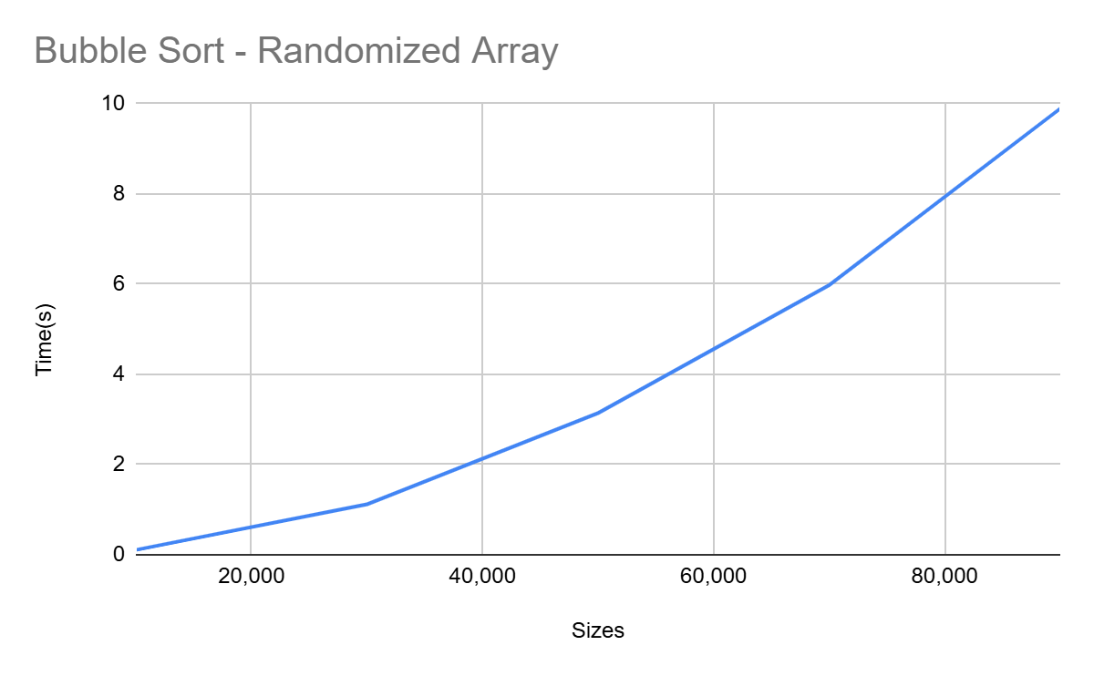
Objects Primitives
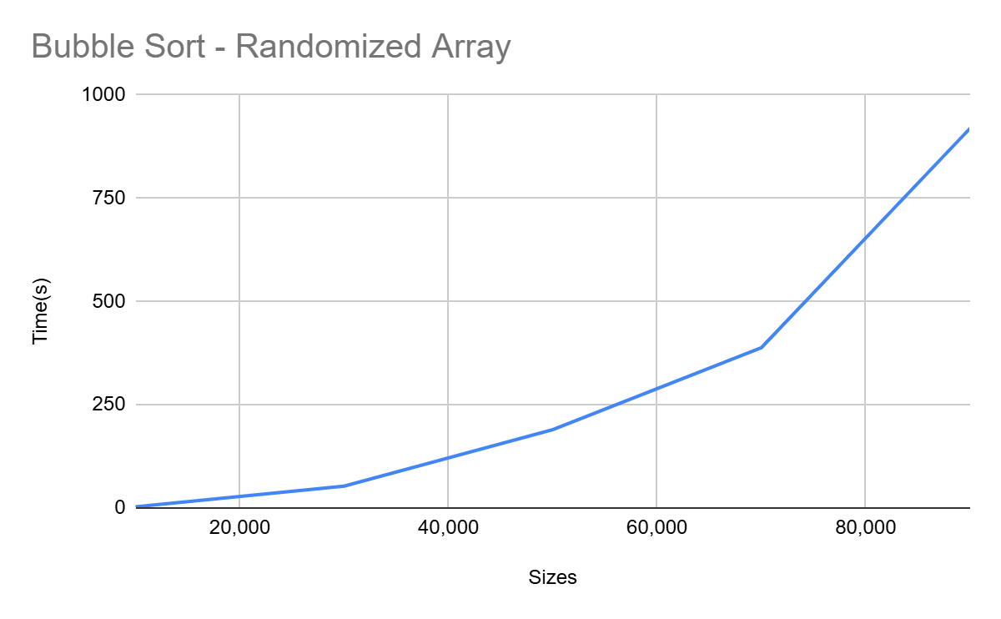
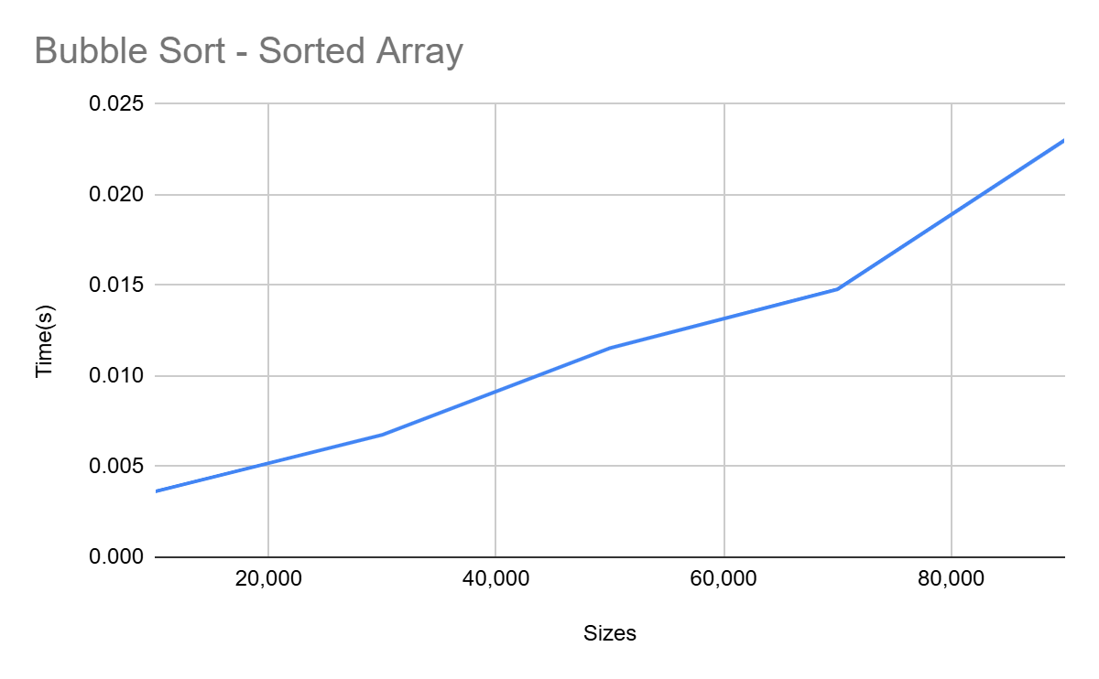
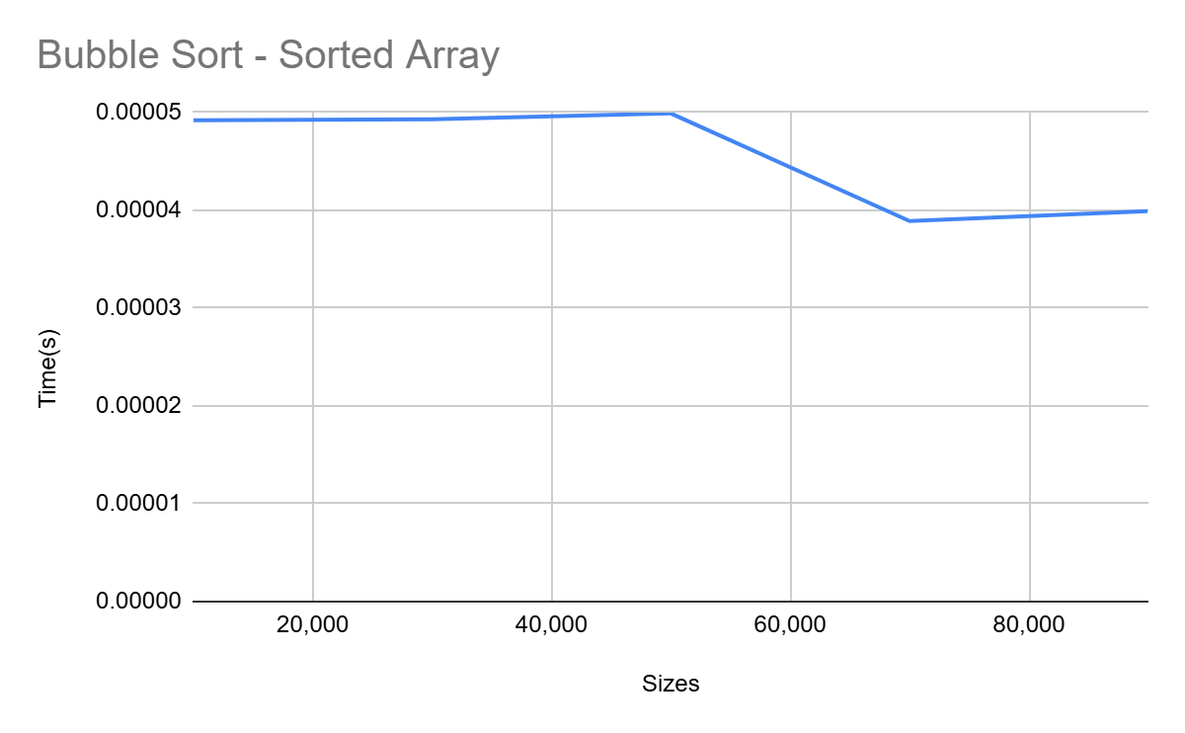

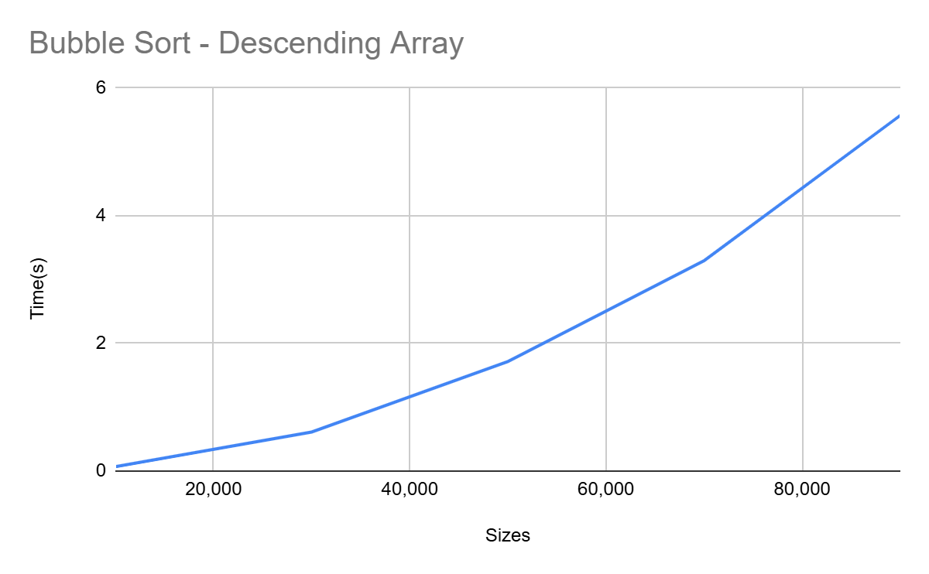
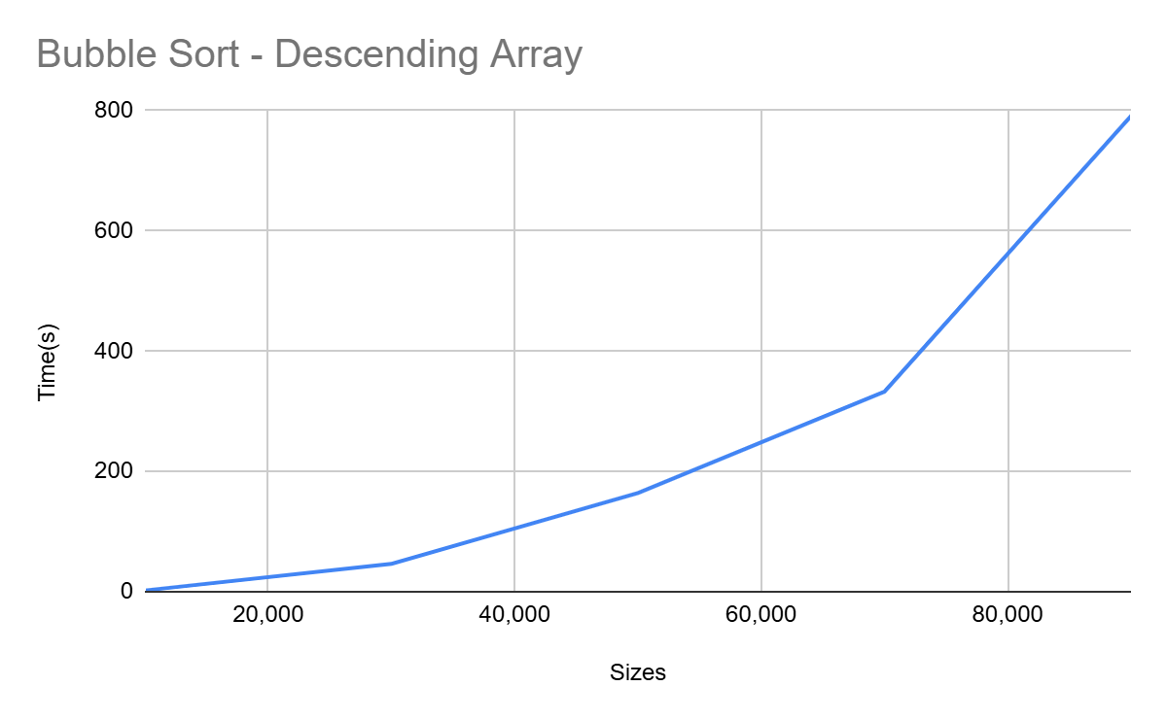
The Graphs show that Bubble Sort’s runtime increases quadratically with randomized, sorted, descending arrays. Performance slowest to fastest - randomized,descending,sorted.

- Selection Sort Performance - Randomized, Sorted and Descending arrays

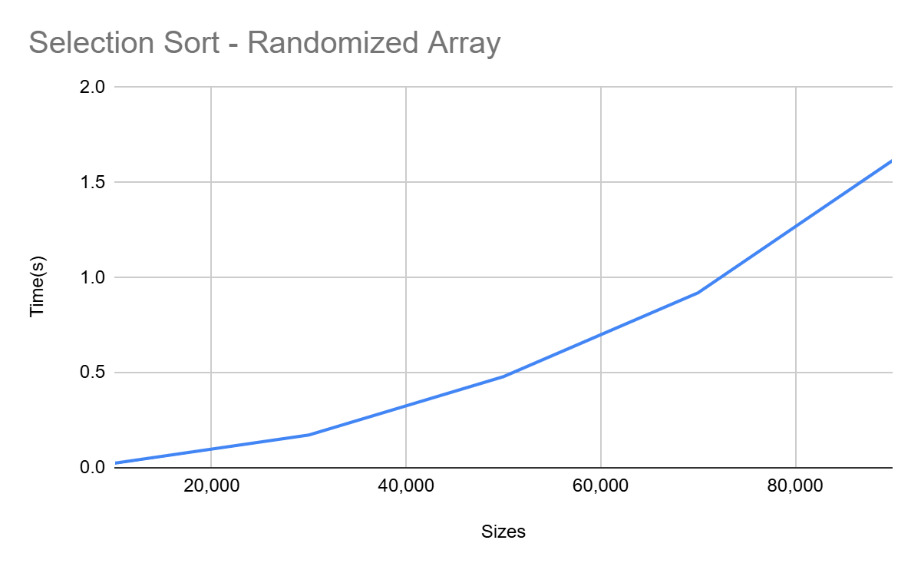
Objects Primitives
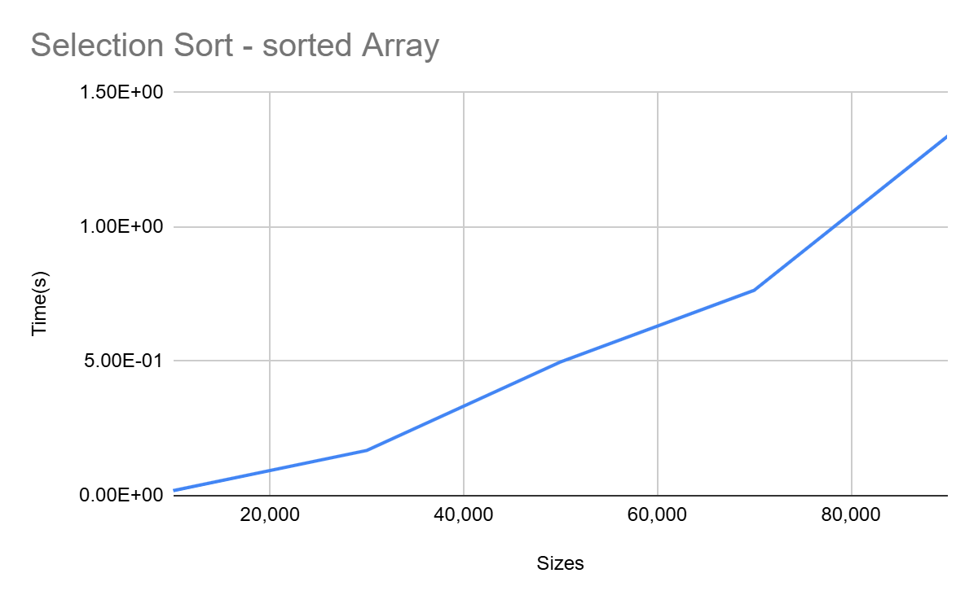
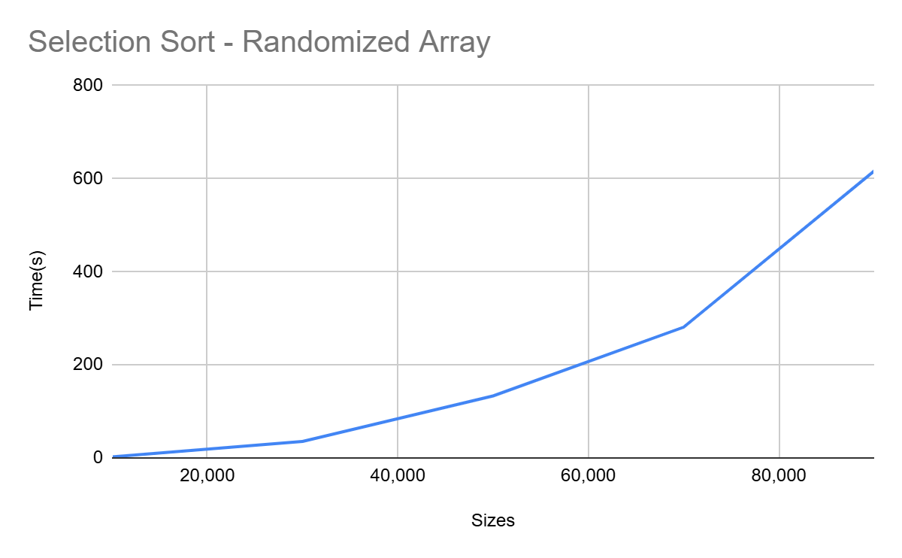

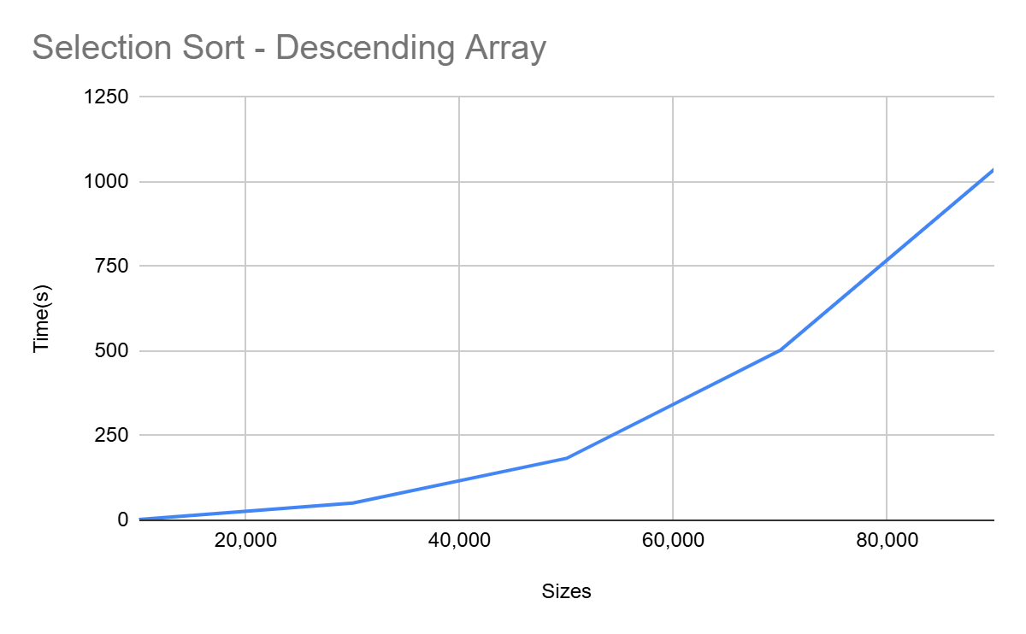
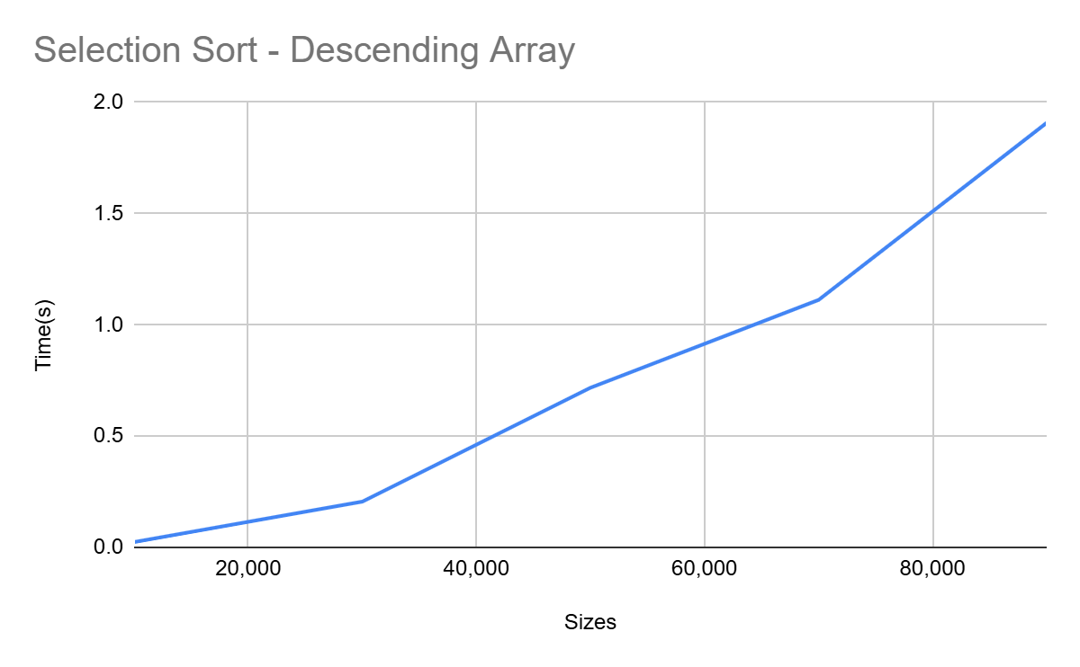
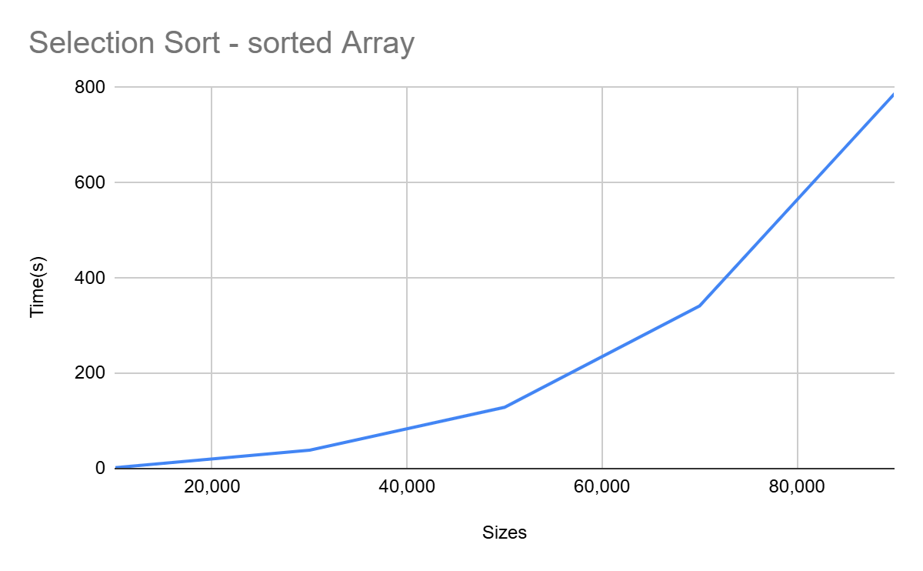

3) Insertion Sort Performance

Objects Primitives

The Graphs show that Selection Sort’s runtime increases quadratically with randomized, sorted, descending arrays. Performance slowest to fastest - Descending, Sorted, Randomized

3) Insertion Sort Performance - Randomized, Sorted and Descending arrays

Objects Primitives

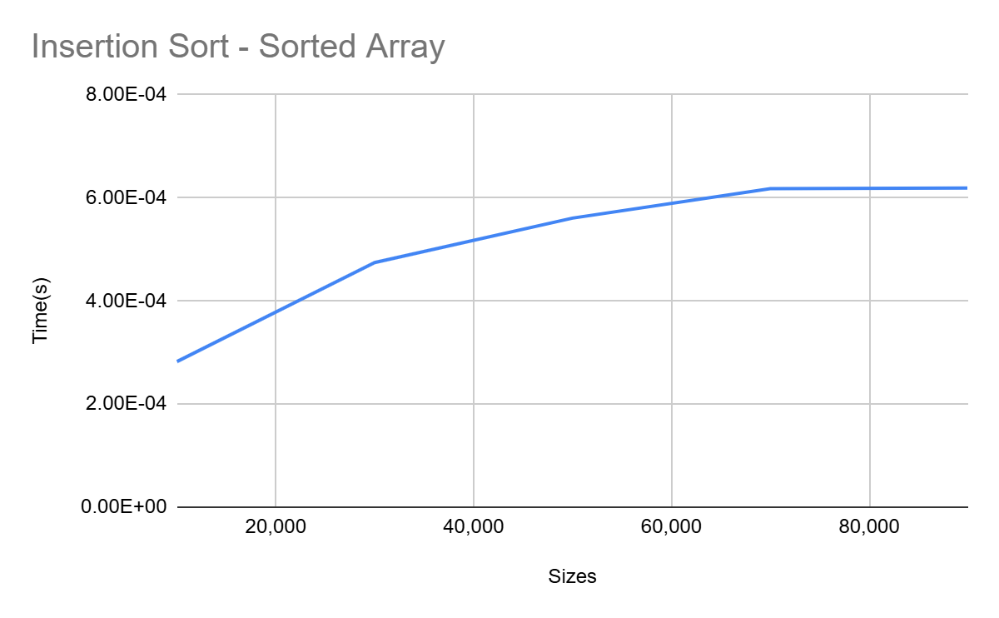
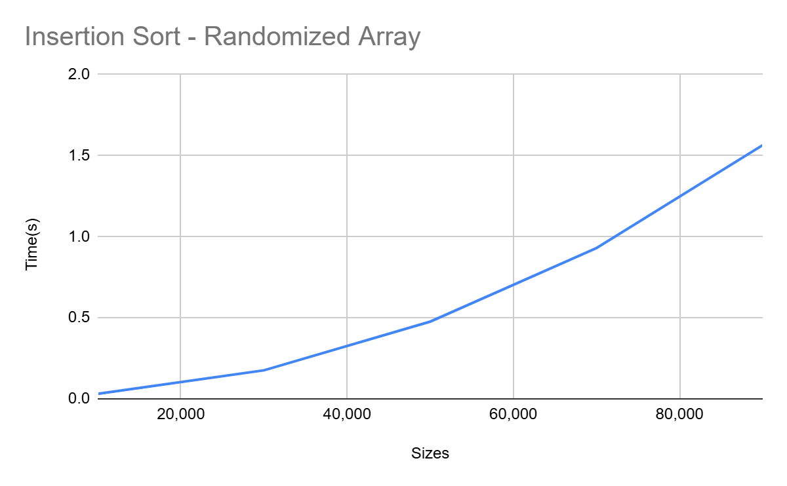
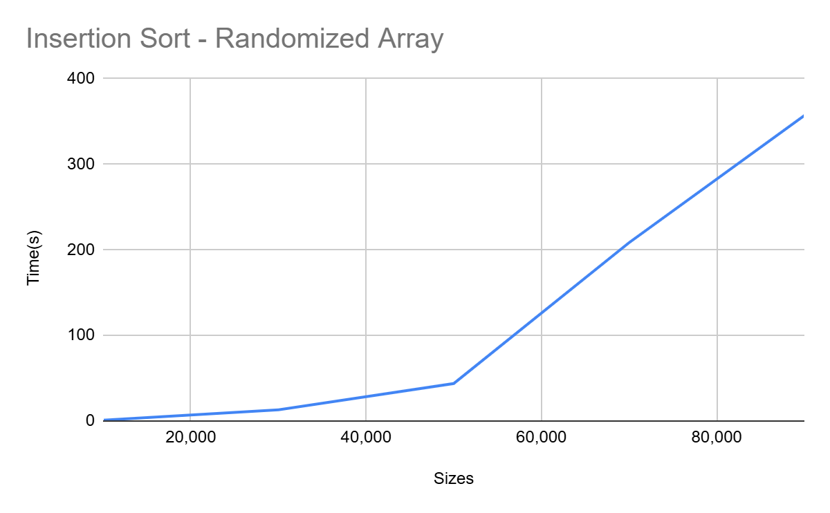
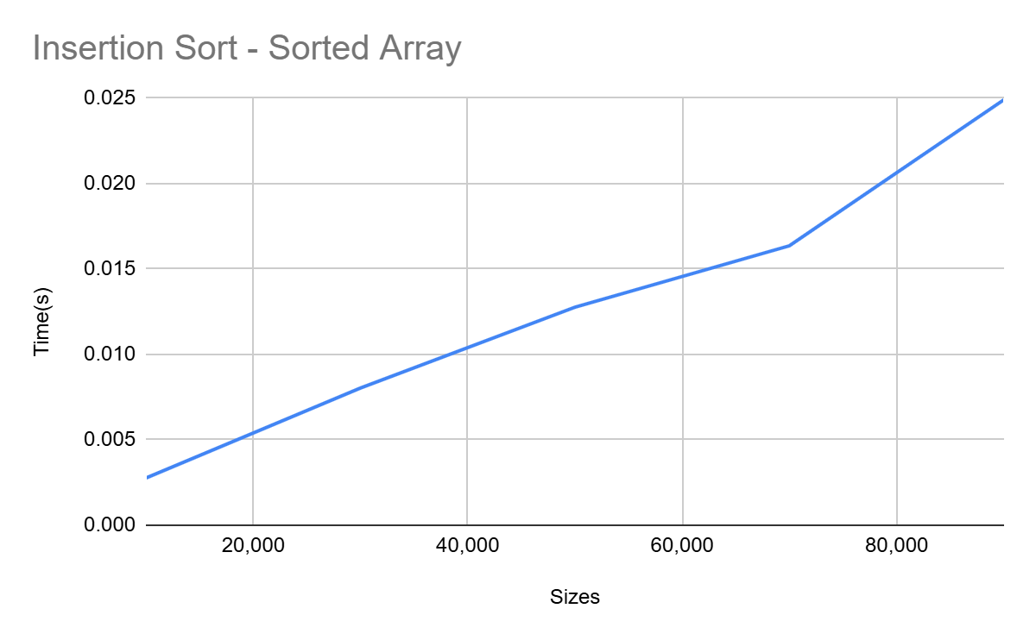
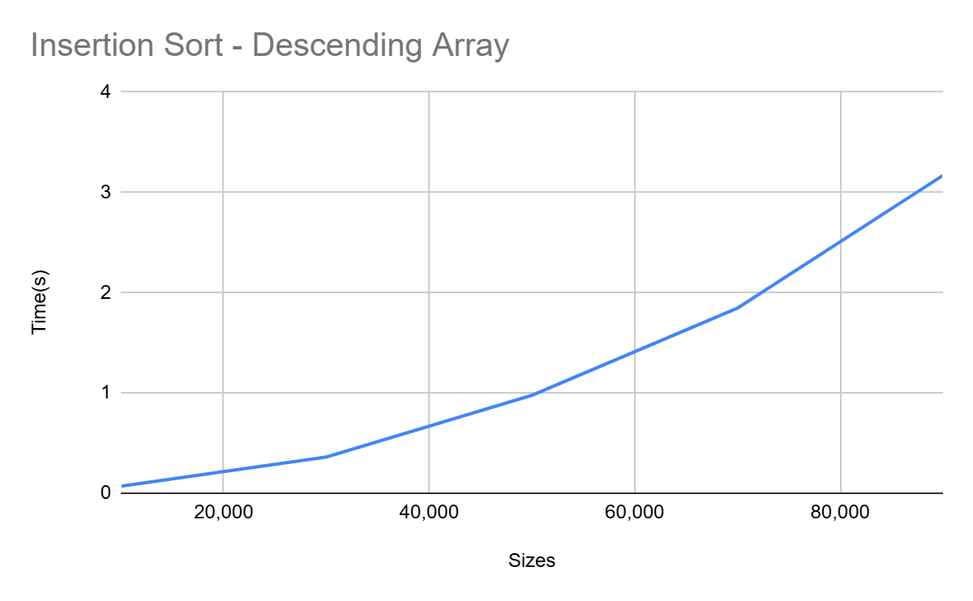
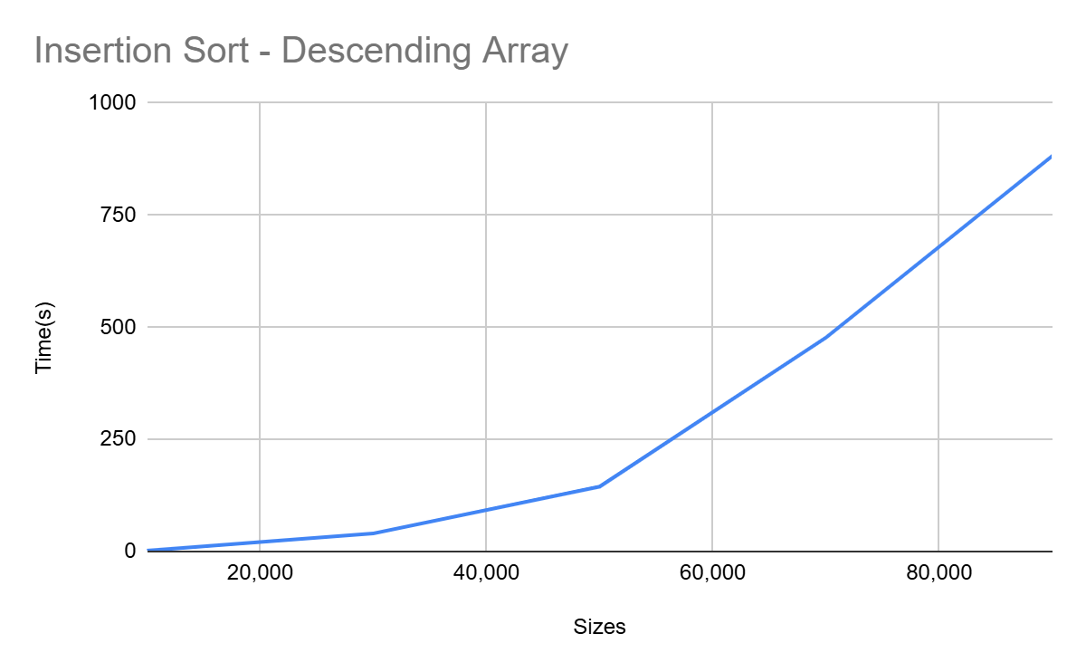

The Graphs show that Insertion Sort’s runtime increases quadratically with randomized, sorted, descending arrays. Performance slowest to fastest - Descending,randomized,sorted.

4) Chart & Graph for Randomized Array comparing Bubble sort, Selection sort and Insertion sort

Objects Primitives

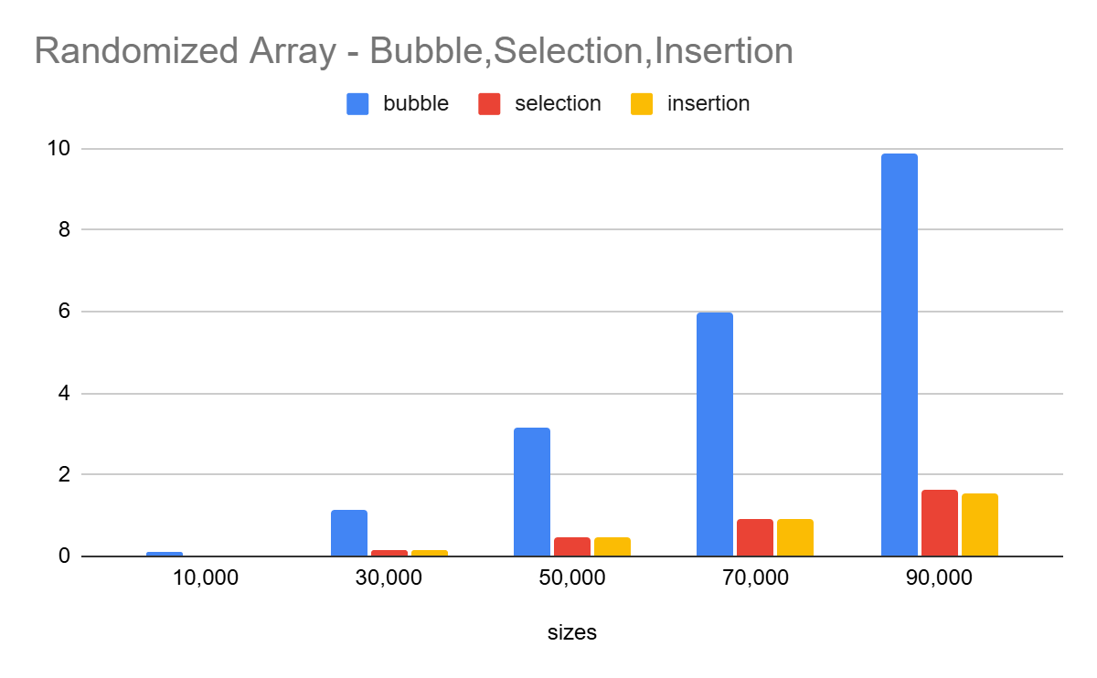
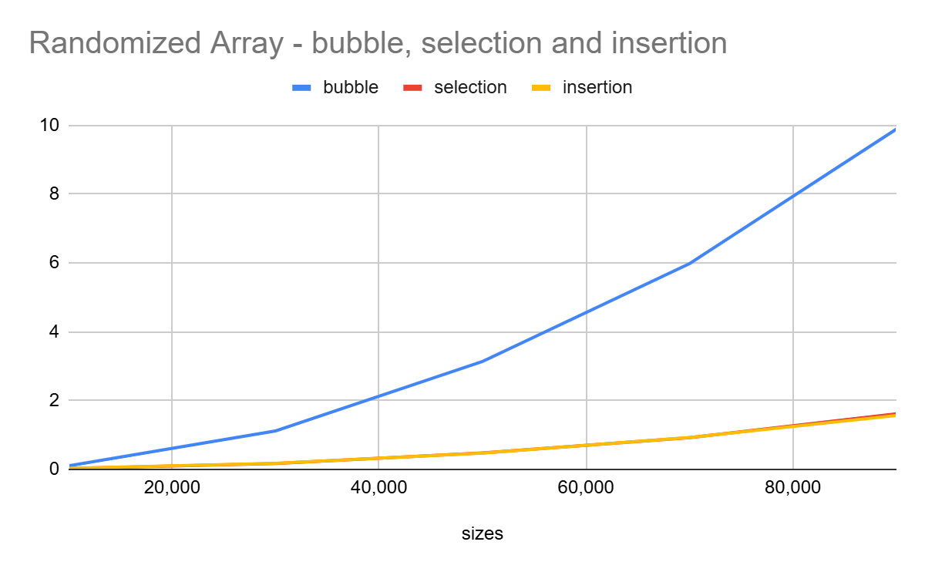
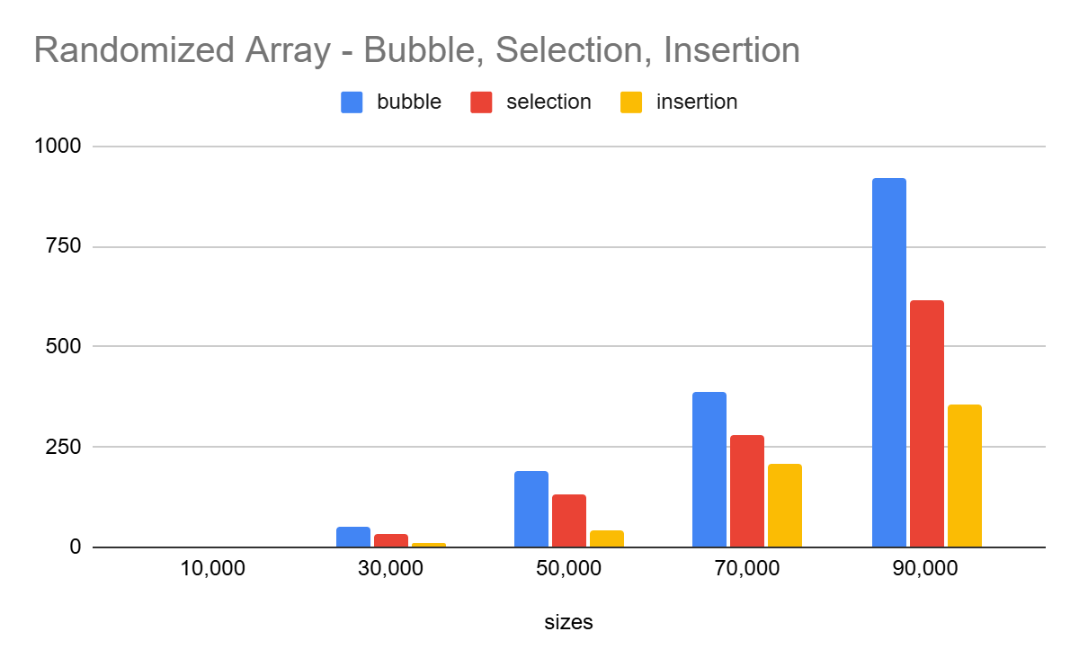
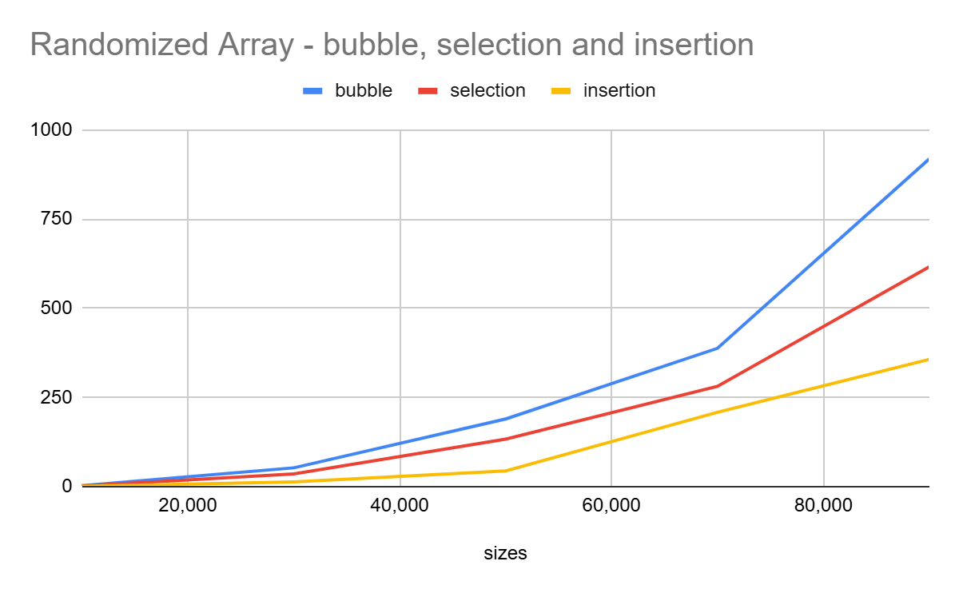
The graphs and charts compare Bubble, Selection and Insertion while sorting randomized Arrays. Performance from slowest to fastest - Bubble sort, selection Sort, Insertion Sort.

Explanation for these graphs:

As the chart and graphs show, bubble sort has the slowest performance, selection sort and insertion sort are relatively close with insertion being fast in most cases. This is majorly because, bubble sort repeatedly compares adjacent elements and swaps them, if they are in the wrong order, so even if the placing is correct, bubble sort keeps checking and comparing them. Even if selection sort is similar to bubble sort, with time complexity O(n^2), it does very few swaps in comparison to bubble sort making it faster, but insertion sort is the fastest despite being O(n^2), it only compares elements until it finds the right place, not the whole array every time. This explains why bubble sort is the slowest, selection sort and insertion sort being the fastest.

5) Chart & Graph for Sorted Array comparing Bubble sort, Selection sort and Insertion sort

Objects Primitives
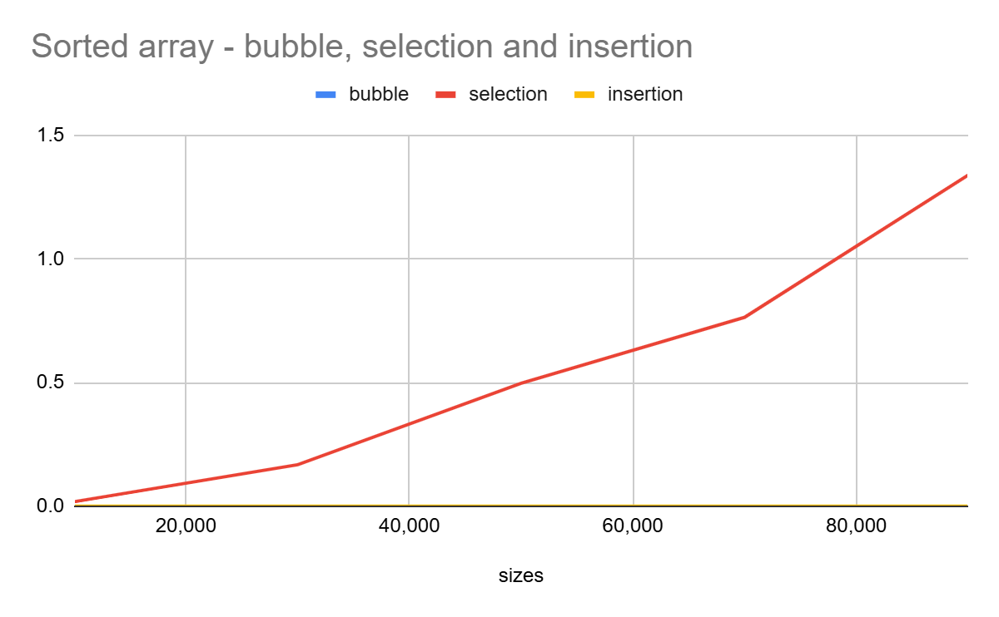
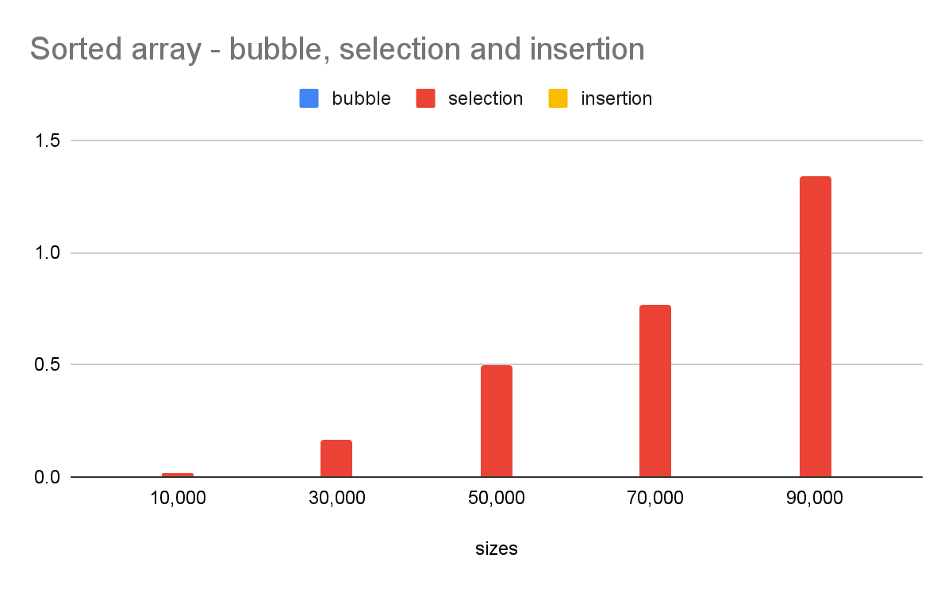
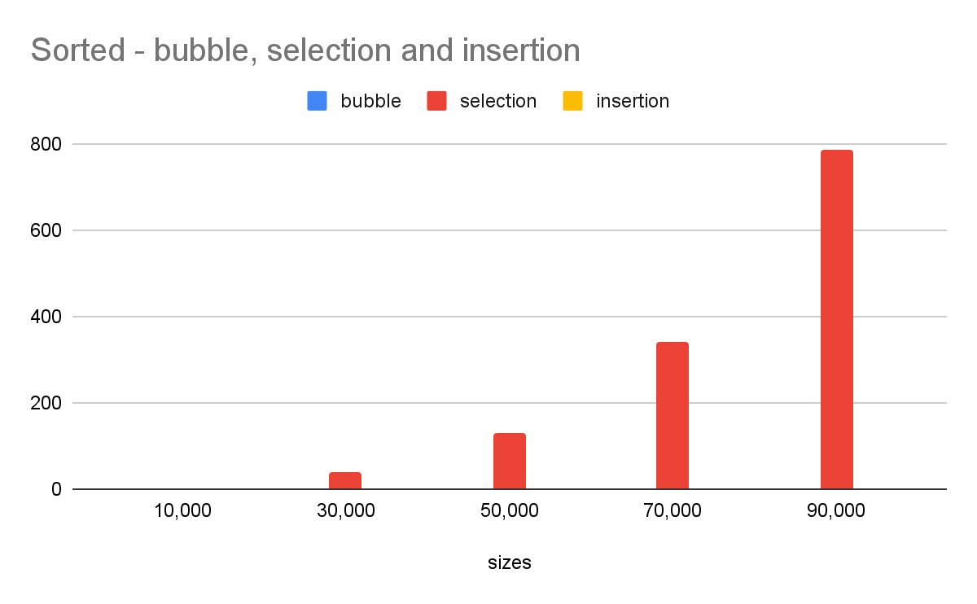
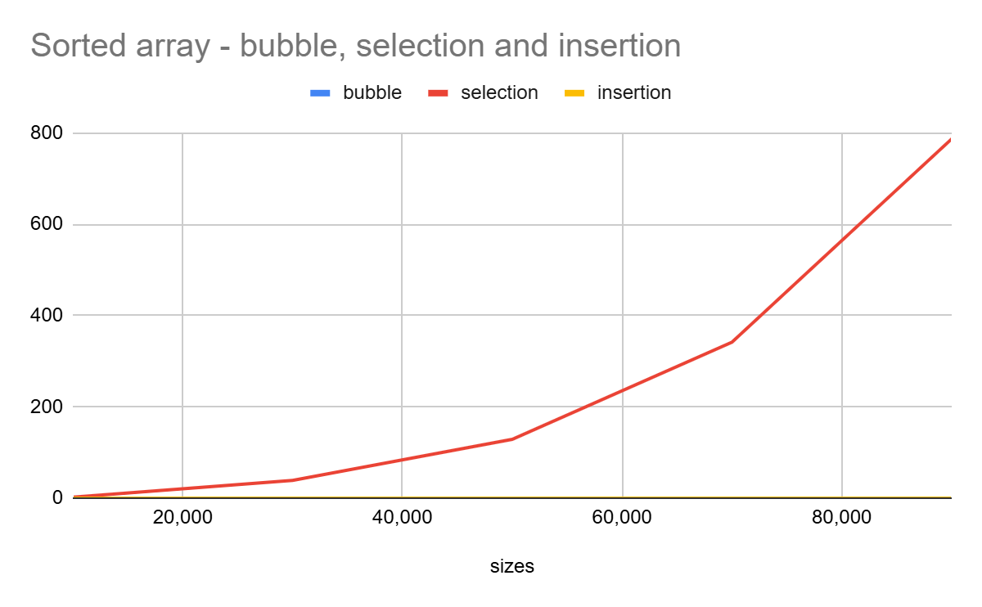
The graphs and charts compare Bubble, Selection and Insertion while sorting Sorted Arrays. Performance from slowest to fastest - Selection Sort, Bubble sort, Insertion Sort.

Explanation for these graphs:

When the arrays are descending, selection sort has the slowest performance, while bubble sort and insertion sort are much faster when the array is already sorted. The reason behind this is that selection sort goes through the entire array to find the minimum element, even when the data is already in order, resulting in the same number of comparisons irrespective of the order of the array. Bubble sort and insertion sort exit the algorithm much faster, avoiding unnecessary passes. Therefore, for sorted arrays, Selection sort performs the slowest due to its constant number of comparisons, while bubble sort and insertion are much faster.

6) Descending Array - Bubble, Selection, Insertion

Objects Primitives
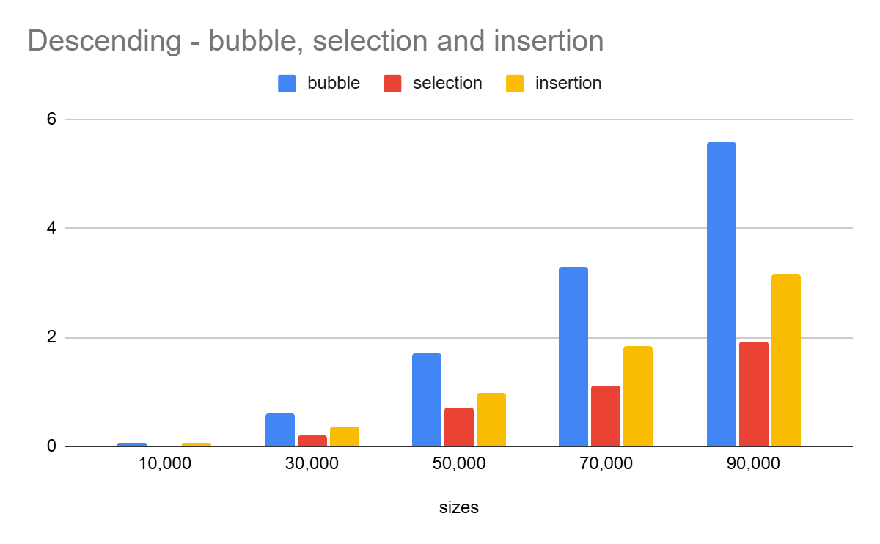
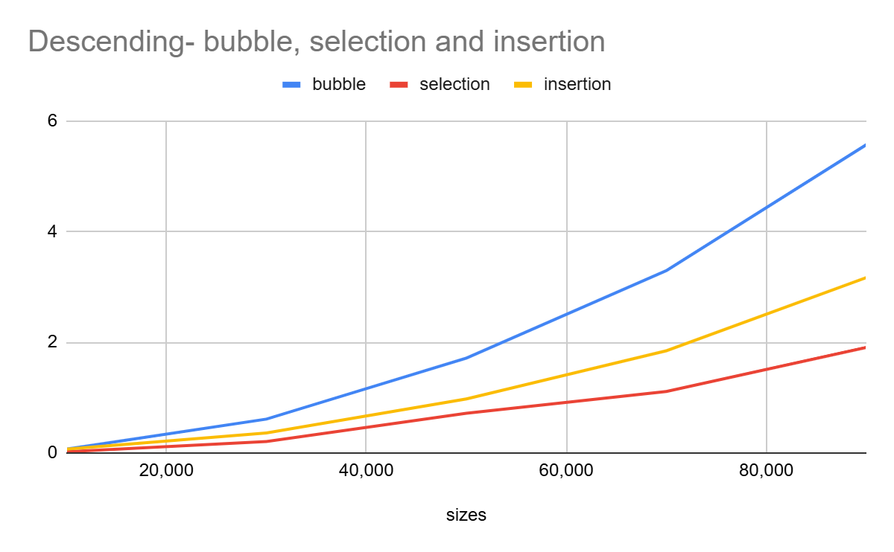
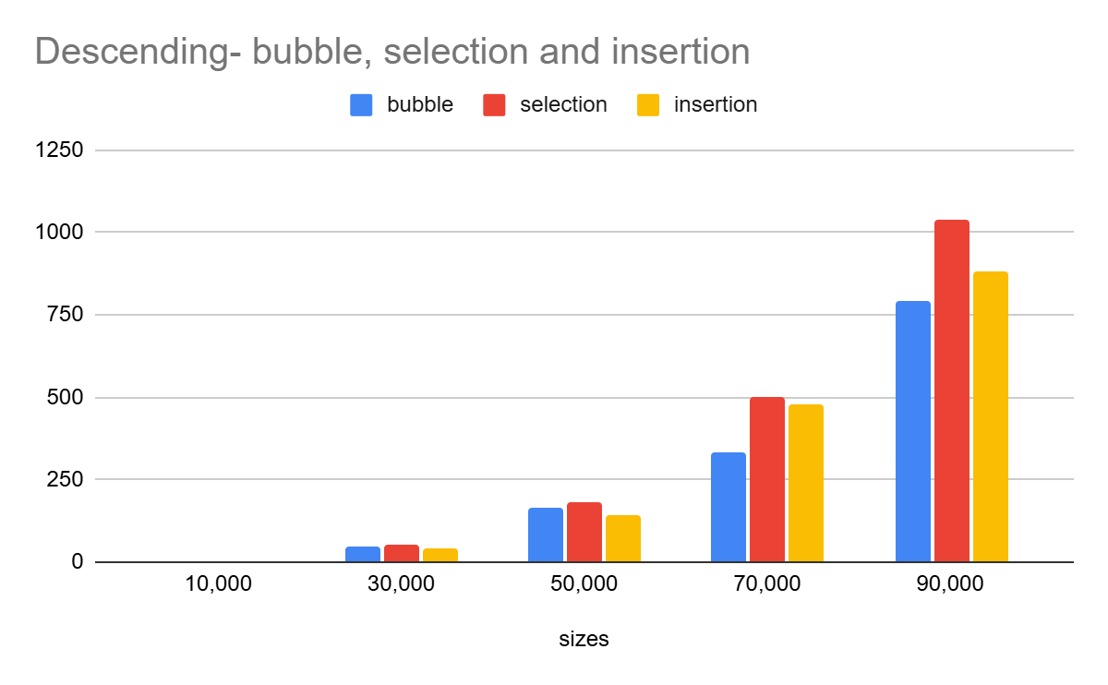
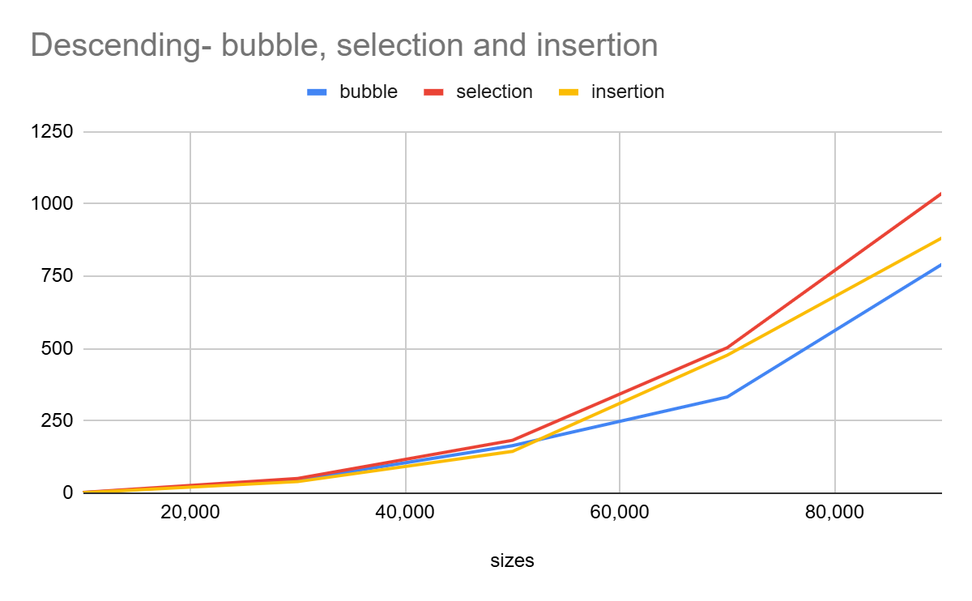
The graphs and charts compare Bubble, Selection and Insertion while sorting Descending Arrays. Performance from slowest to fastest -
Objects: Selection sort, Bubble Sort, Insertion Sort.
Primitives: Bubble sort, Insertion Sort, Selection Sort.

Explanation for these graphs:

When the arrays are descending, all three algorithms perform worse, as this is their worst case scenario. Selection sort remains consistently slow because it always scans the entire array, regardless of order. Bubble sort and insertion sort slow down significantly, since every element must move through many comparisons and swaps to reach its correct position. Bubble sort requires the maximum number of passes, while insertion sort repeatedly shifts elements before inserting. Overall, selection sort stays inefficient, but bubble and insertion sorts suffer the most in descending order due to the high number of swaps and comparisons.
Explanation For Graphs in Part A (Question 1, 2, 3):

1) Bubble sort graphs: The graphs in this section compare the performance of bubble sort on randomized arrays, sorted arrays and descending arrays using objects and primitives. The graph shows that as the size increases, the time taken to sort these arrays grows Quadratically, which leads to it showing a graph that looks like a quadratic function. This is the reason for its big O notation to be O(n^2). The only exception present is when the graph is in sorted order, and this makes sense because when an array is sorted, bubble sort's time complexity is O(N), as such, the graph line is linear in the sorted array graphs.

2) Selection sort graphs: The graphs compare the performance of selection sort on randomized arrays, sorted arrays, and descending arrays using objects and primitives. These graphs also show that the runtime increases quadratically as array size grows. These graphs show that the algorithm's performance is consistent because it always makes the same number of comparisons, irrespective of the order in which the array is present. Overall, the graphs also show how selection sort works quadratically and has the time complexity, O(n^2).

3) Insertion Sort Graphs: These graphs also show quadratic behavior as seen through the graph. This happens because each element must be compared and should be shifted/inserted to its right position, which also becomes slower with larger data sets. Overall, these graphs also show how insertion sort works quadratically and has the time complexity, O(n^2). Similarly to bubble sort, its graph line in a sorted array is more linear, this is because just like bubble sort, insertion sort has a linear runtime when used on a sorted array.

Why primitives run significantly faster in comparison to objects:

For objects, the runtime increases much more than primitives because it takes the algorithm to access each object property (a map) and uses the string objects compareTo() method for each comparison, making it take longer time, leading to a slower performance. Primitives run much faster because these comparisons and swaps happen directly in the memory without using objects.

Part B:

- These sorts are called “quadratic sorts” because of their quadratic time complexity, shown through the Big O notation(O(n^2)).The main reason behind this is because their runtime increases proportionally to the square of the number elements or the size of the input data (n^2), where n is the number of elements.The runtime increases proportionally because these sorts use nested loops because the outer loop iterates through every element in the input data and the inner loop also iterates through a subset of the list. This double iteration is what leads to n * n (n^2), so for example the number of elements in input data is doubled, these sorts take about 4 times as long to complete.

- Insertion sort is the most efficient for random arrays in both objects and primitives data. The data shows that it repetitively has the lowest time among the three for randomized arrays.For example, at an array size of 10000, bubble sort takes 2.8 seconds, selection takes 2.1 seconds while the lowest is insertion sort with 0.8 seconds. This is because it only shifts elements until it finds the right position, instead of making unnecessary swaps like the other two sorts.

- Bubble sort is the least efficient sort for a reverse ordered array because it takes the maximum number of swaps(repeatedly swaps adjacent items) as every element is out of order, making it take longer to sort the data, in comparison to selection and insertion sort.This is clearly represented through the graph in Part a, question 6.

- Insertion sort on an already sorted array produces a linear time O(n). This happens because while insertion sort is being run on an already sorted array, the inner loop does not make any swaps, while only comparing each element once, this also applies to bubble sort. selection sort does not produce a linear time because it still performs all the comparisons making its sorts take longer to exit the program.

Part C:

Code:

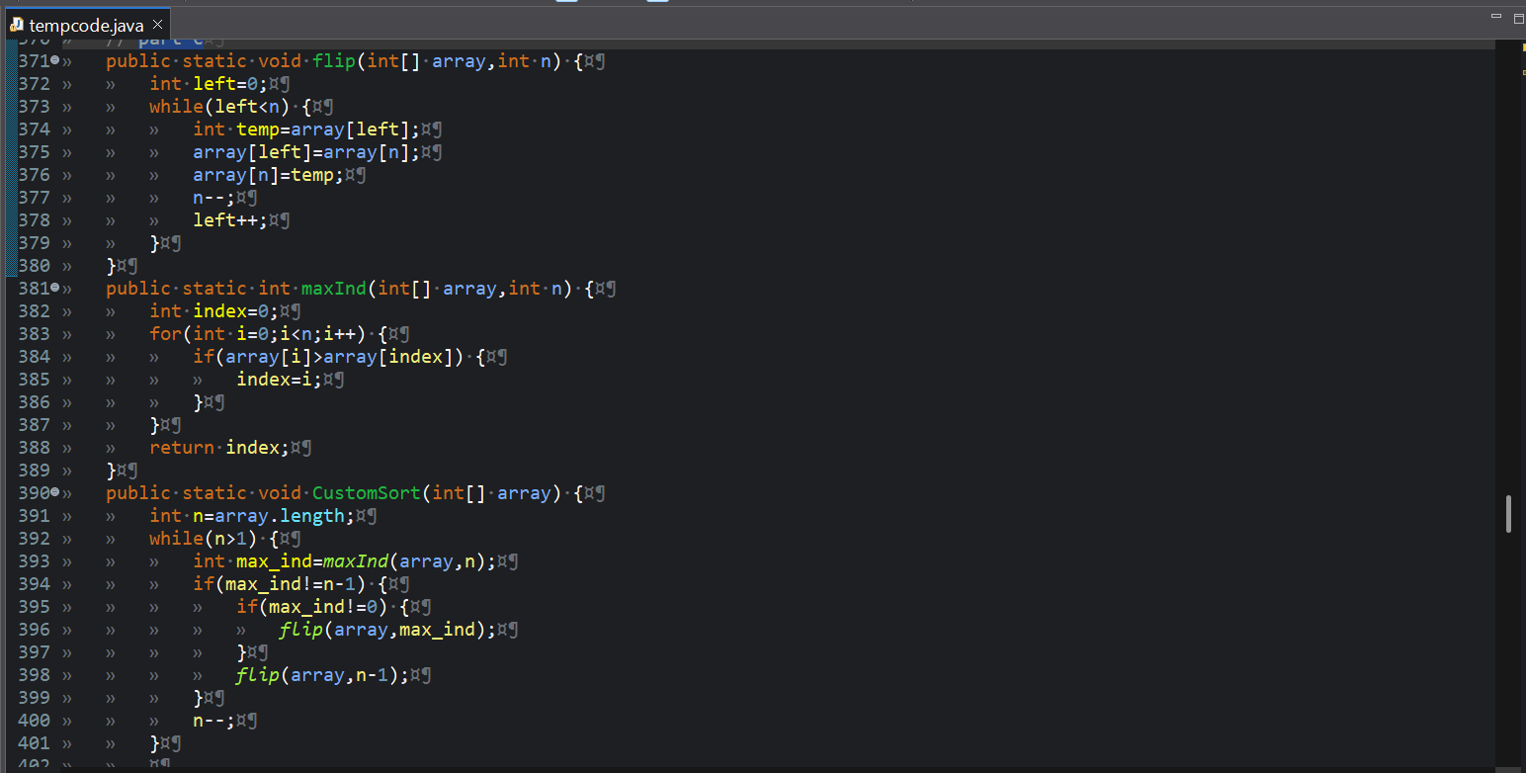
For primitives

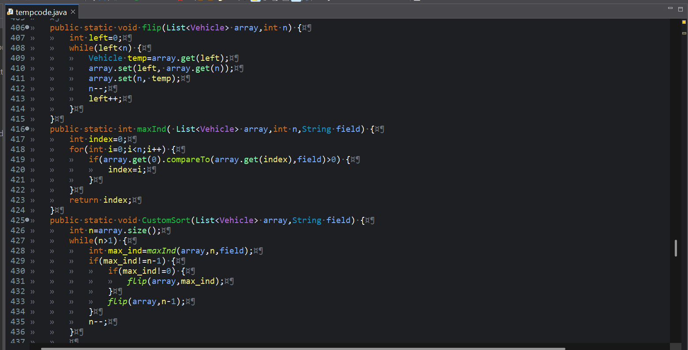
For Objects

Explanation:

The difference between this sort and the other ones that we have used so far is that this one first finds the index of the highest element so far in the array, then it flips it with the unsorted elements all the way until the max element reaches the front of the array, then it does a second flip, of the entire array, so that the max element reaches its final position at the end of the array. The index that the element ends up at, all the way until the end of the array, is considered sorted, much like selection sort. Then the algorithm finds the next highest element, and the process repeats.
Compared to the 3 other quadratic sorts (bubble, selection and insertion) pancake sort’s average and worst case time complexity is also O(n^2). It is most similar to selection sort in that it’s best case time complexity is O(n^2), unlike bubble sort and insertion sort. All 4 of these sorts have a space complexity of O(1) or a constant space complexity.

